**Terms of reference**

**1**.Main page - the page we see as soon as we enter the website

There is a map in the center

* + *Authorized* users can see their visited places or set marks on the map, scroll. The user will see header and settings

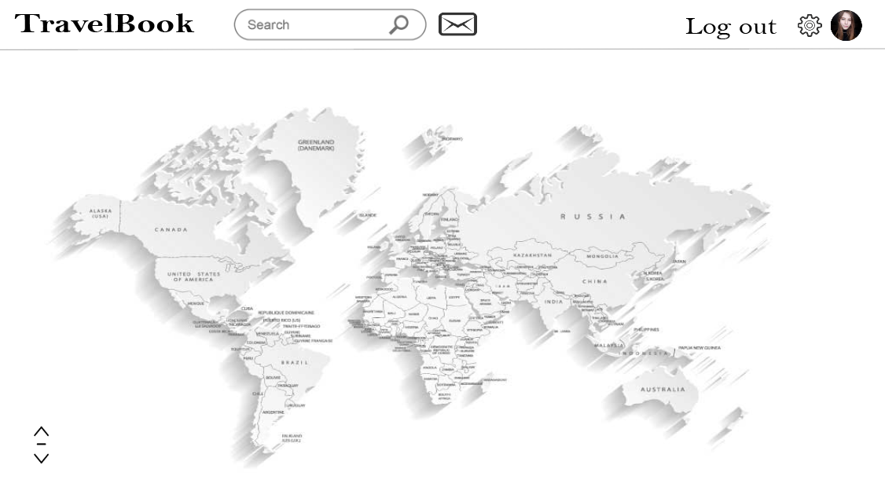

* + *Unauthorized* users will see only the map, header, form of registration, form of log in, scroll

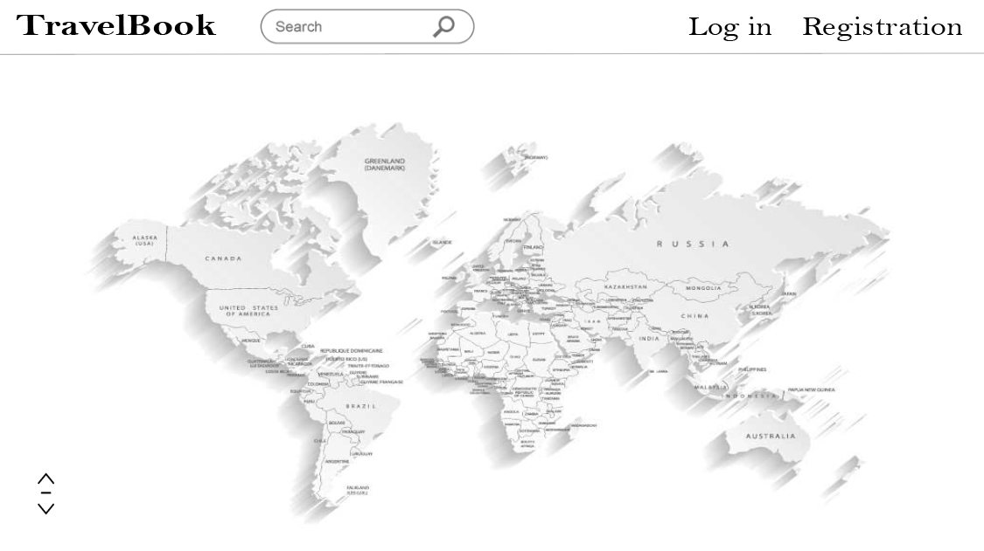

**2.** After clicking on the specific place, additional panel appears on the right. There you can see four icons :

* + General Information

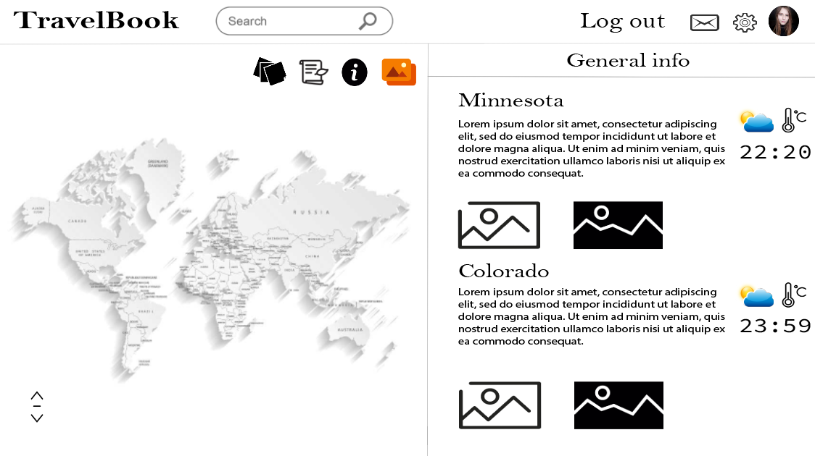

* + Notes

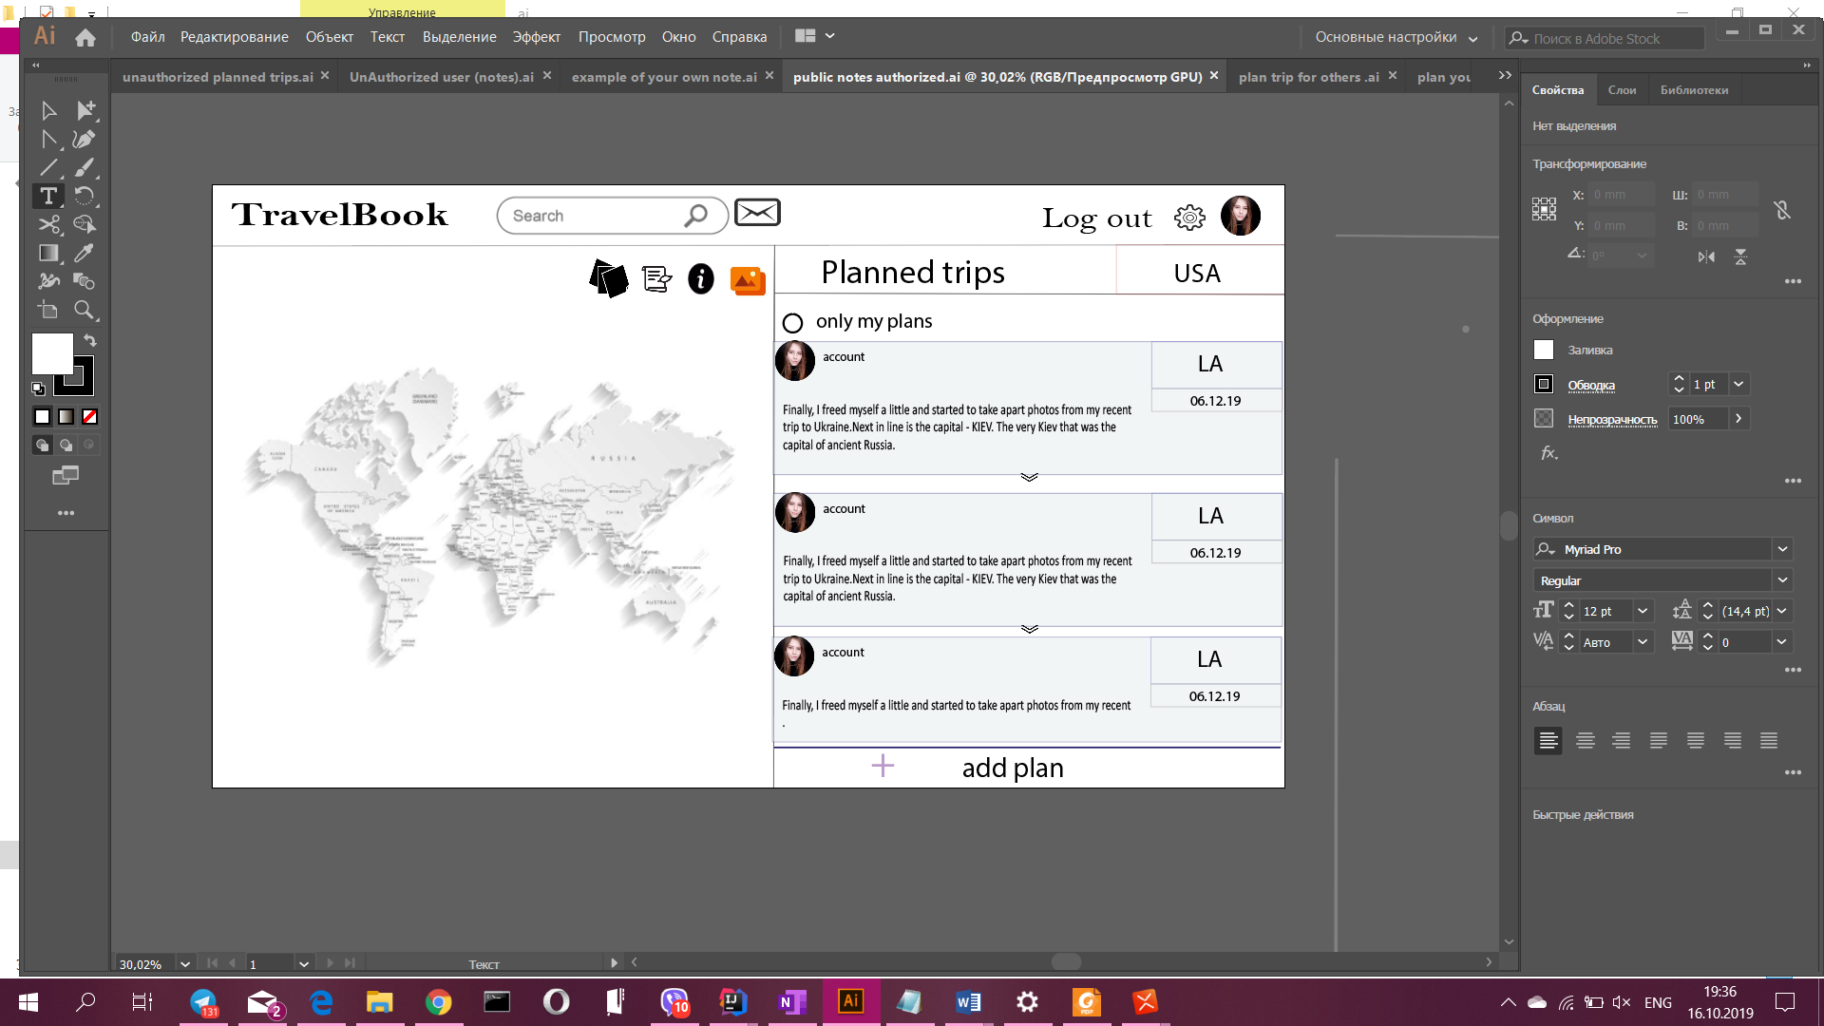

* + Planned Trips
  + 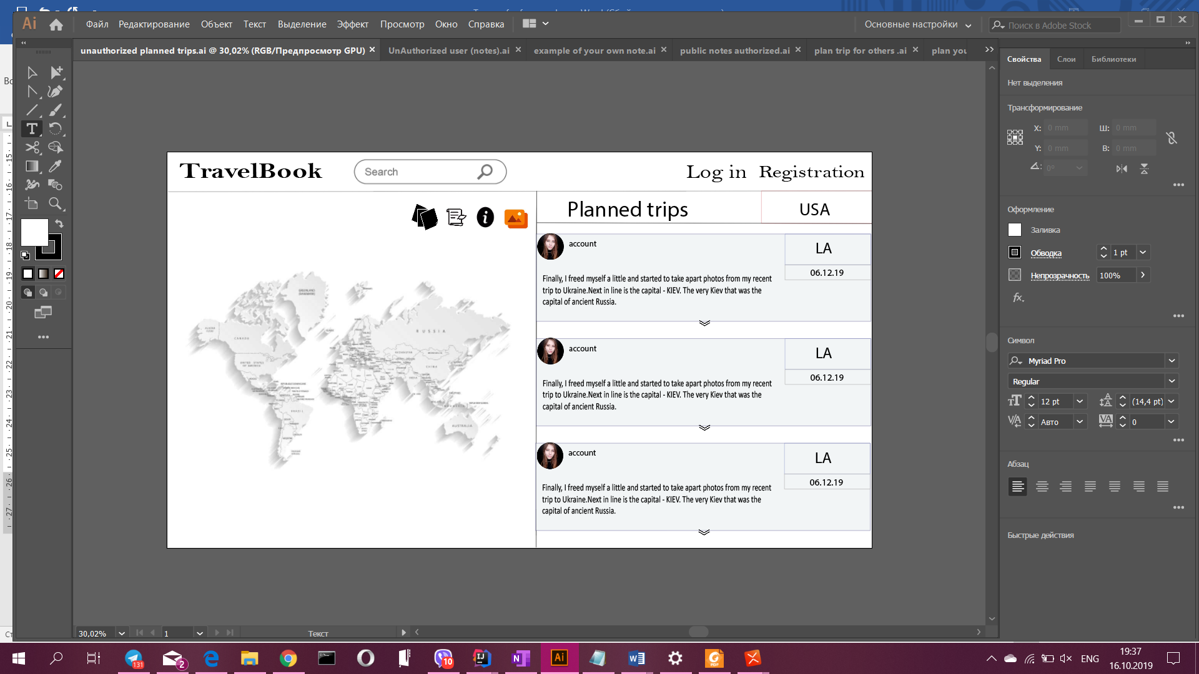
  + Gallery

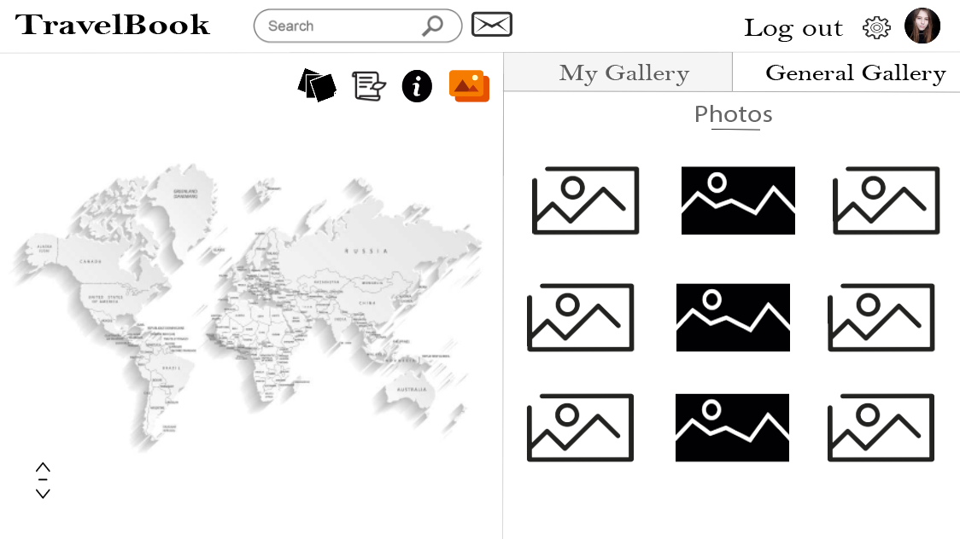

3. Settings

There *authorized* users can set specific details about themselves such as

* + First and last name
  + Change the login
  + Change the password
  + Add or change only one avatar
  + Delete the account

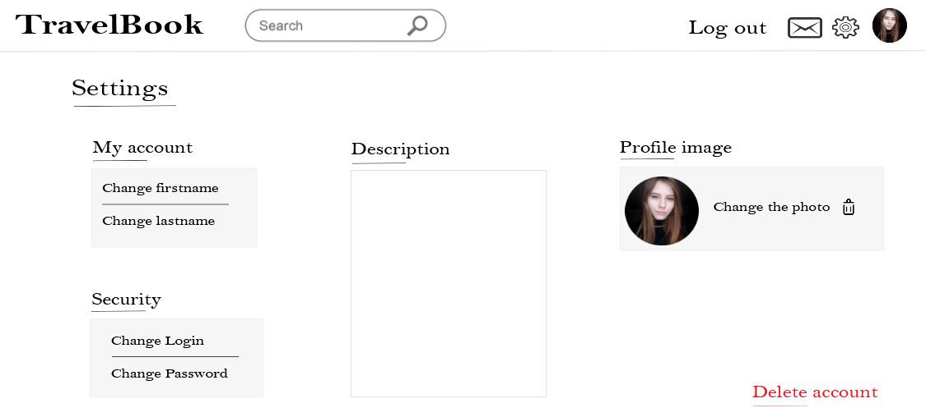

***Informational panel***

* + **General Information**

The user can read some small description of the country (place or a city). There also be some photos of the main sights.

The next functionality is the weather in that specific place at this moment (also we may add functionality to see current time in that place).

You can see the rating of that place. That rating is based on the estimation of the users.



* + **Notes**

Public notes - are the notes, that other people post about this place, the place they visited.

**Without account** you can only look at the photos and read these posts.

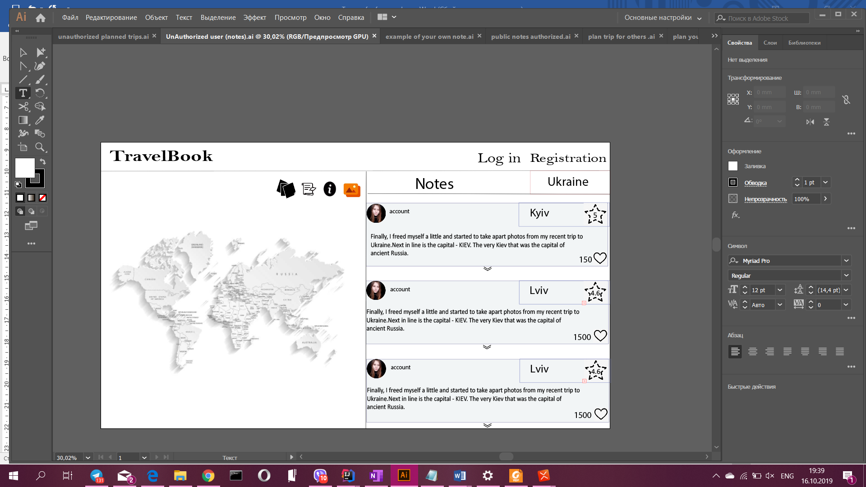

***Authorized*** users will have a checkbox (my notes) that shows what notes to show. If checked - shows only your notes, that you have made about this place, otherwise all the notes of other people.

There is a button (Add note) that lets users to add new Note about the place we clicked.

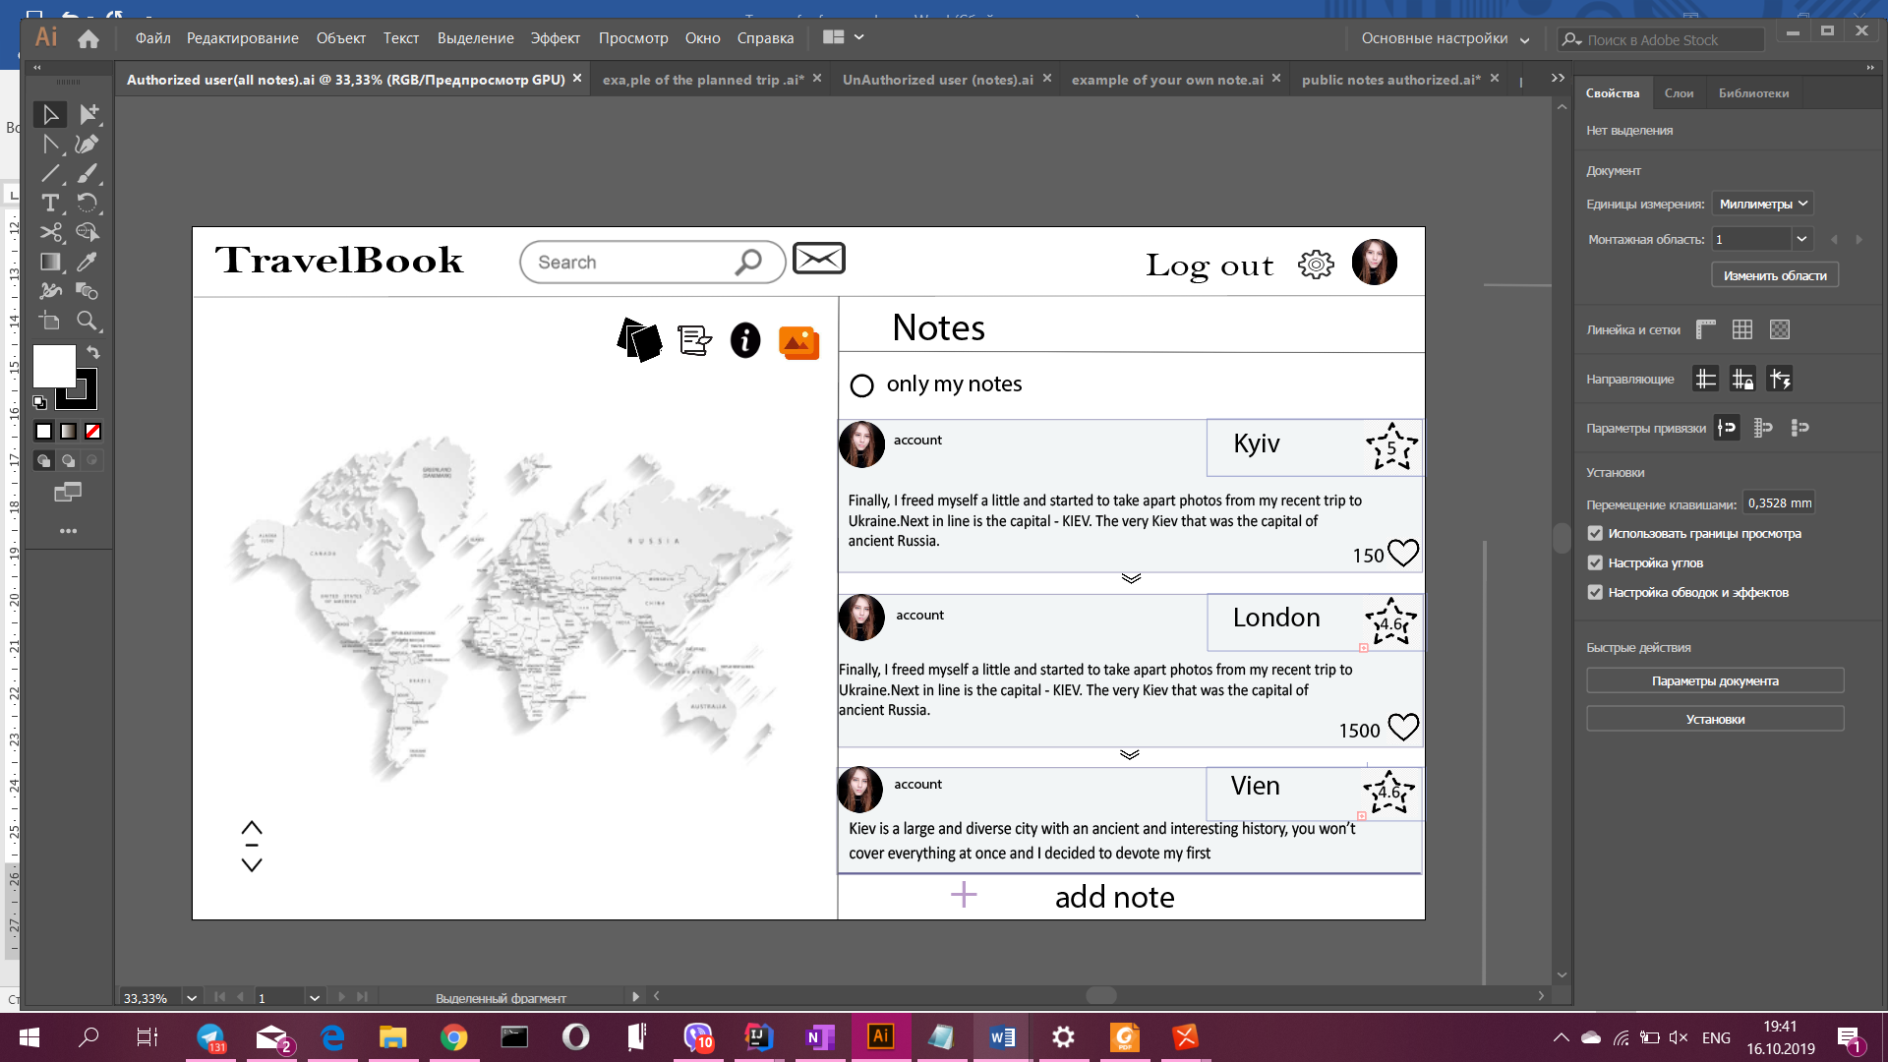

**Add note**

After clicking that button there will be a panel on which:

* + The county will be selected already.
  + The user can write about the specific city.
  + The user can add the date of the trip.
  + The user writes his or her own thoughts about the place.
  + Panel for estimations (grades, stars or anything else). Can be on different sections (people, general impression, architecture, money)

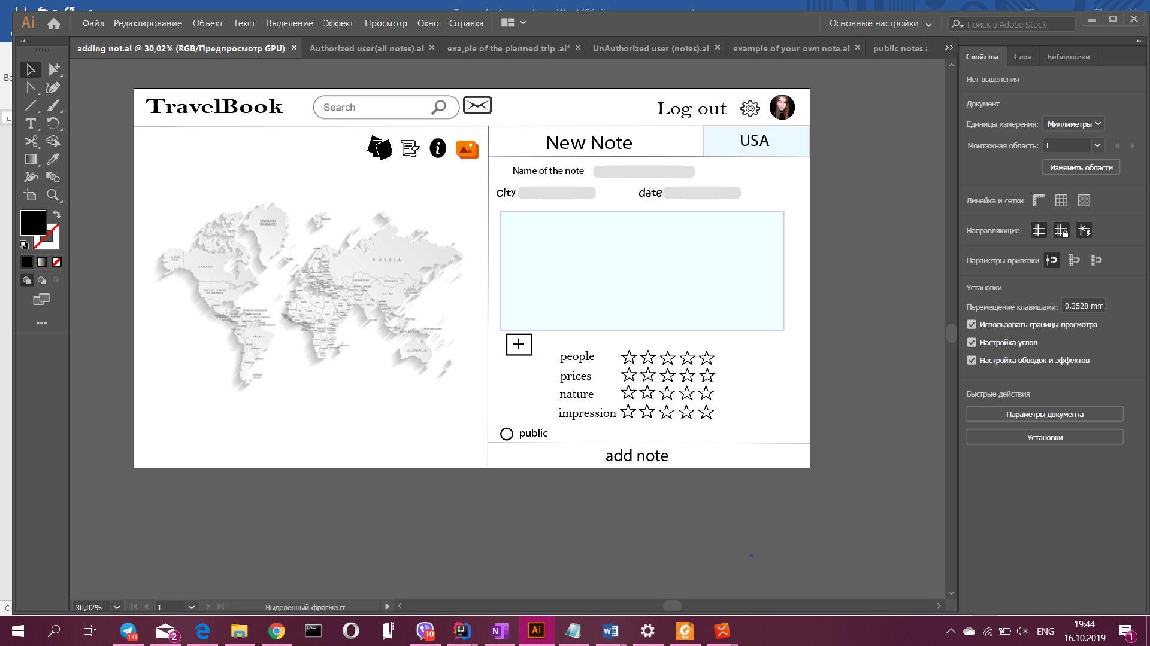

* + **Planned Trips**

Planned trip notes - are the notes that people write for the future.

After clicking on the icon the user sees all the planned notes of others(They are shown only partly, to read everything, we need to click on the trip )

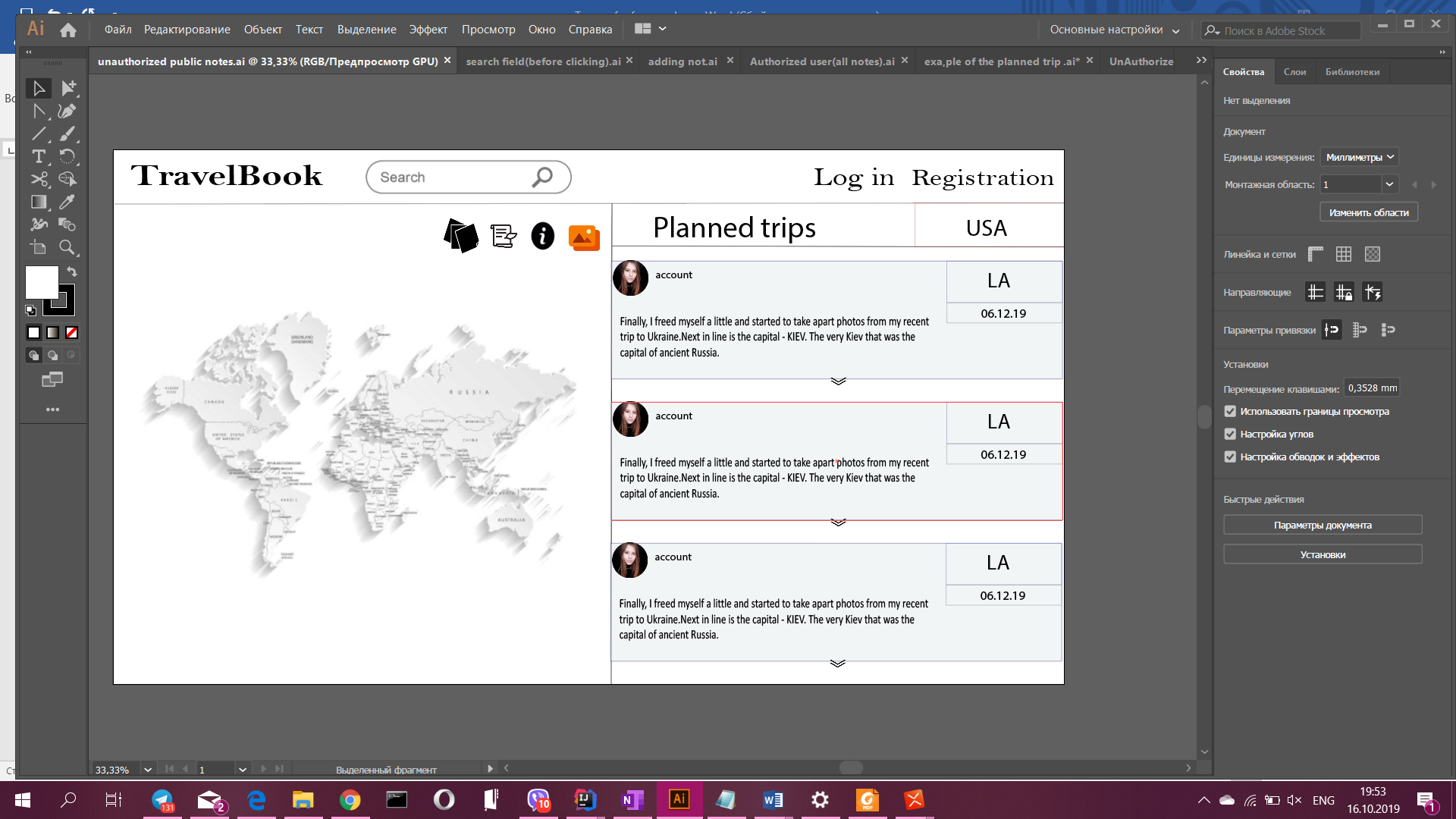

After selecting specific note we can see all the details of the trip

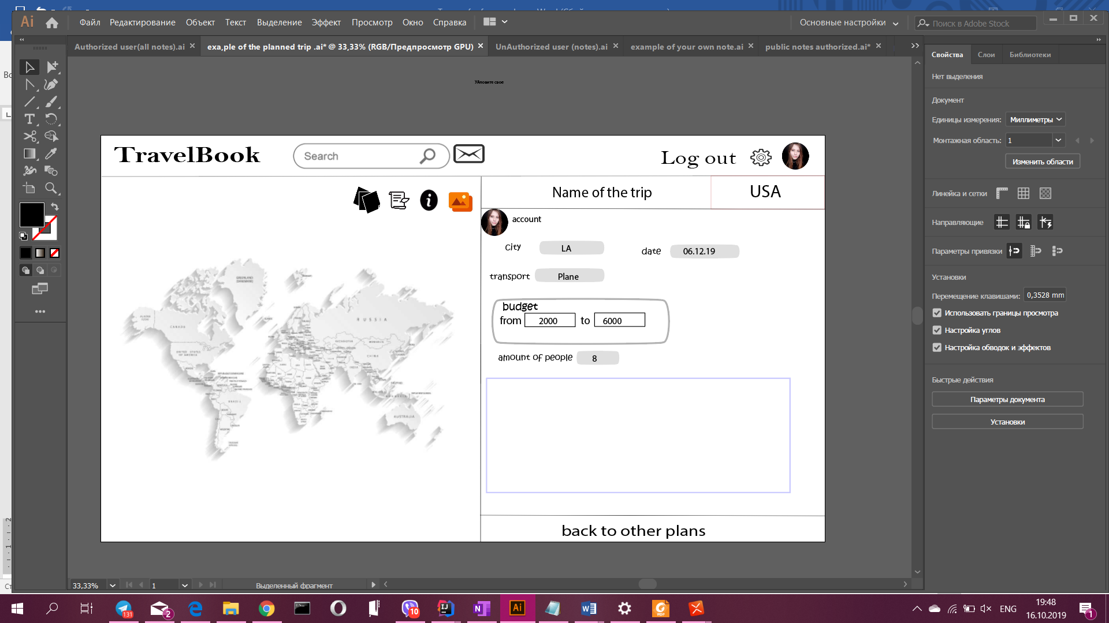

***Authorized*** users will have a checkbox (*only my plans*) that defines what notes will be on the panel. If checked - shows only your planned trips, that you have made about this place, otherwise all the plans of the other people.

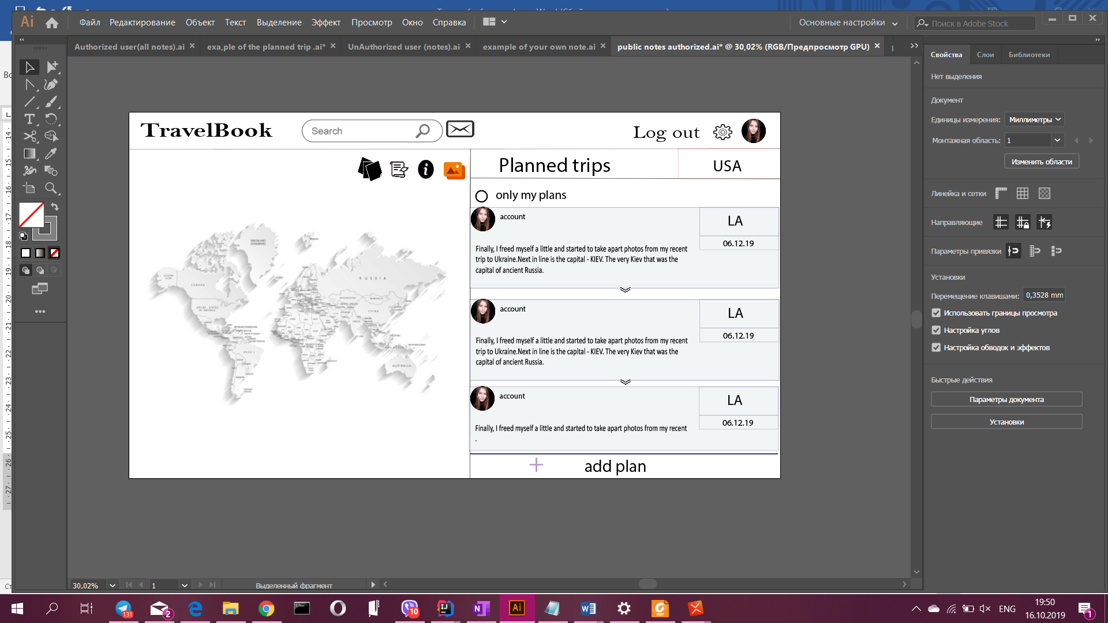

They can be two types - trip that involves other people and others can enroll to this trip, and the trip that you plan only for yourself.

**Plan Trip**

* + The county is already selected.
  + The user can write about the specific city.
  + The user can add the date of the trip.
  + The user can select the type of the vehicle.
  + Write some text about the whole trip like a plan

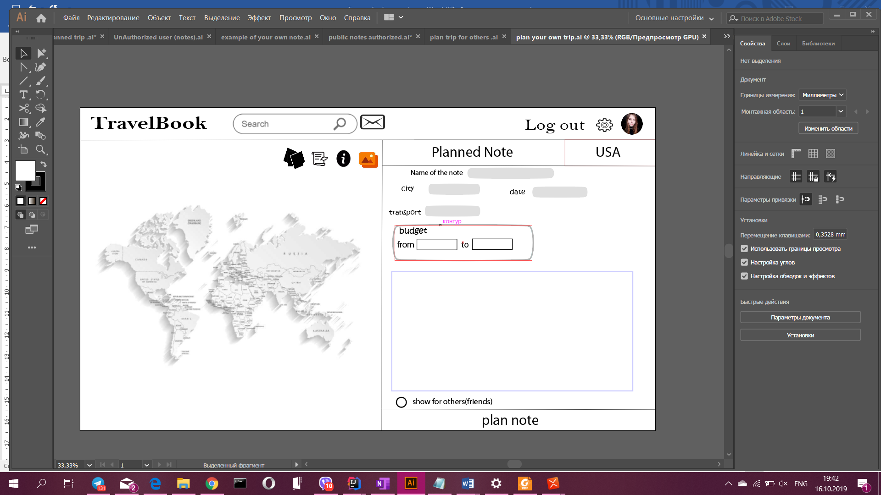

**Trip for others**

* + Can write the amount of people that can join the trip.

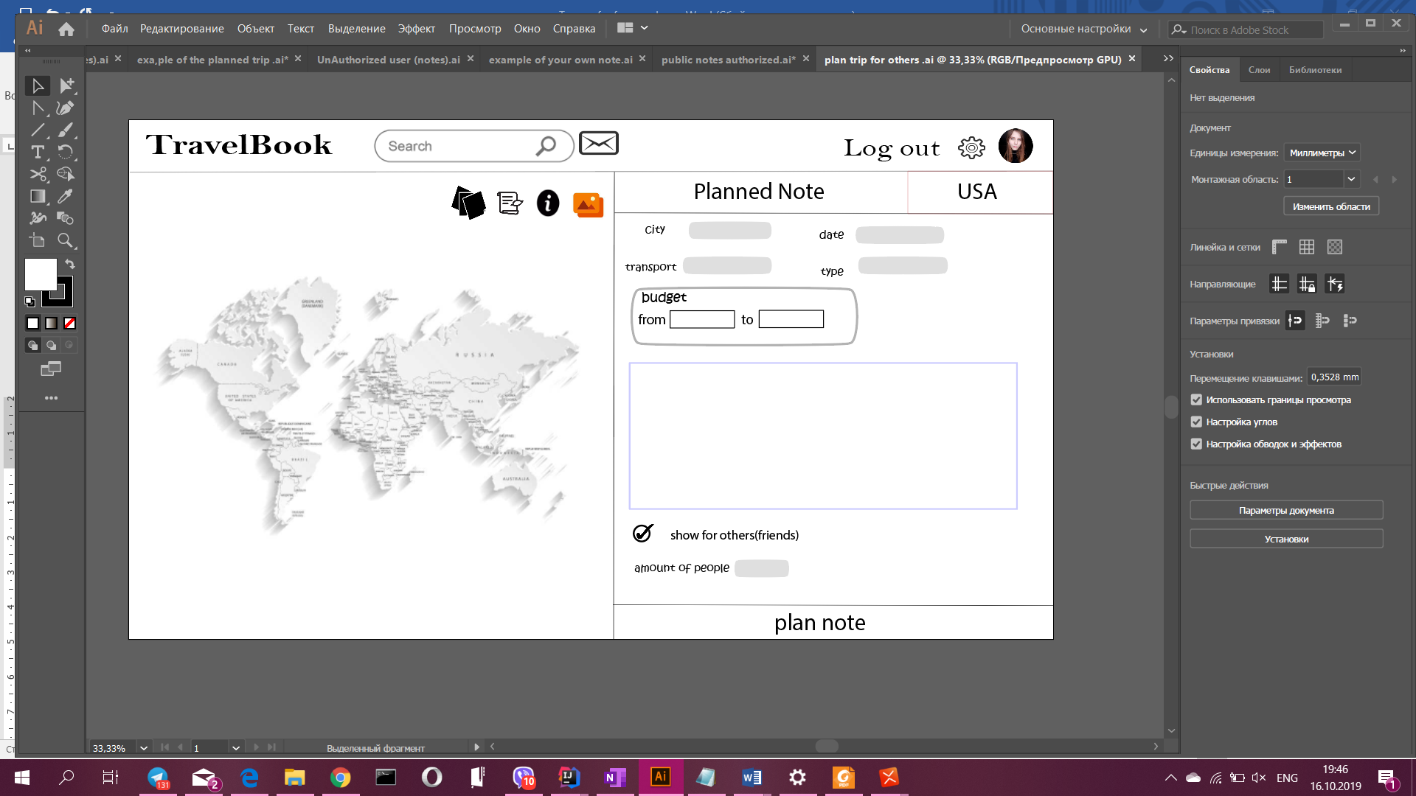

* + **Gallery**

The gallery is the panel where we can see the photos of people collected from all the notes of the people. Authorized users will have a checkbox (my photos) that will define what photos to show.

If checked then it shows only your photos from that place.

***Searching***

**Search for future trips:**

We will another button for only searching for the future trips with filters. It will redirect the user to another page where we will have a panel on the left where we specify the parameters of the search and the other side (on the right) will show all found proper trips. As soon as we are on this page (we have not tried to find anything), we can see the recommendations (future trips) based on our preferences

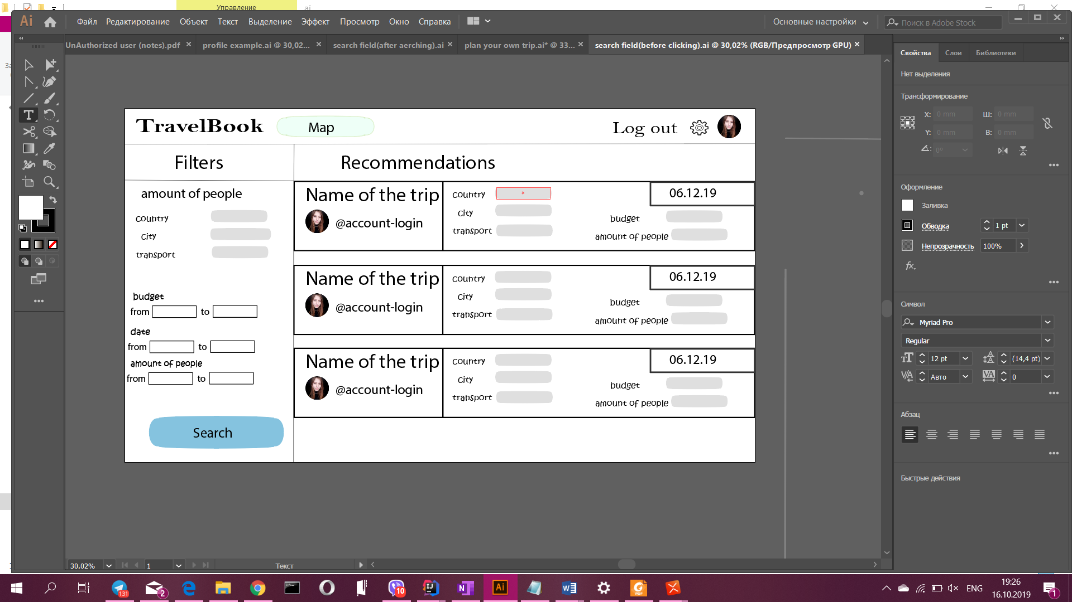

After searching we are getting the results

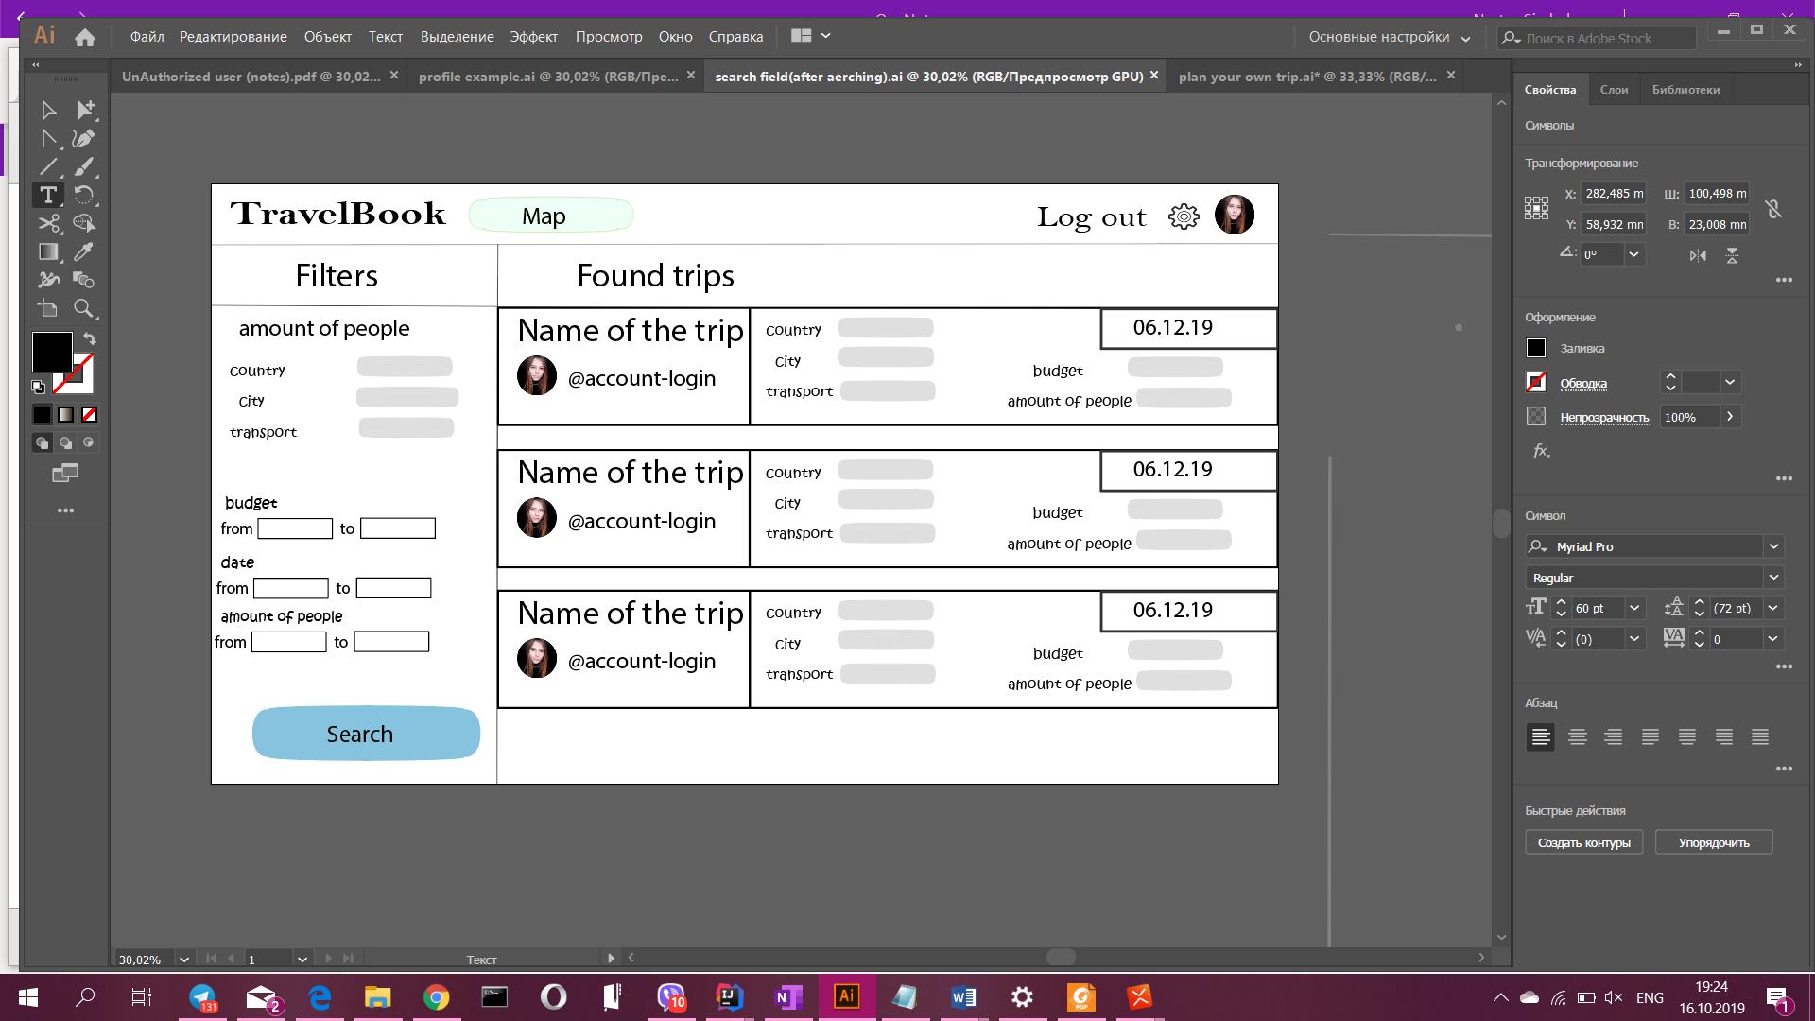

**Searching for users**

We can look through sb’s account, after searching and clicking on the profile we can see the map of the user(Some visited countries may be filled with colors).There also will be an informational panel but notes, planned trips, gallery will be connected with the user and nothing else.

In addition, there is an additional panel in an informational panel that shows the description of the profile of the user.

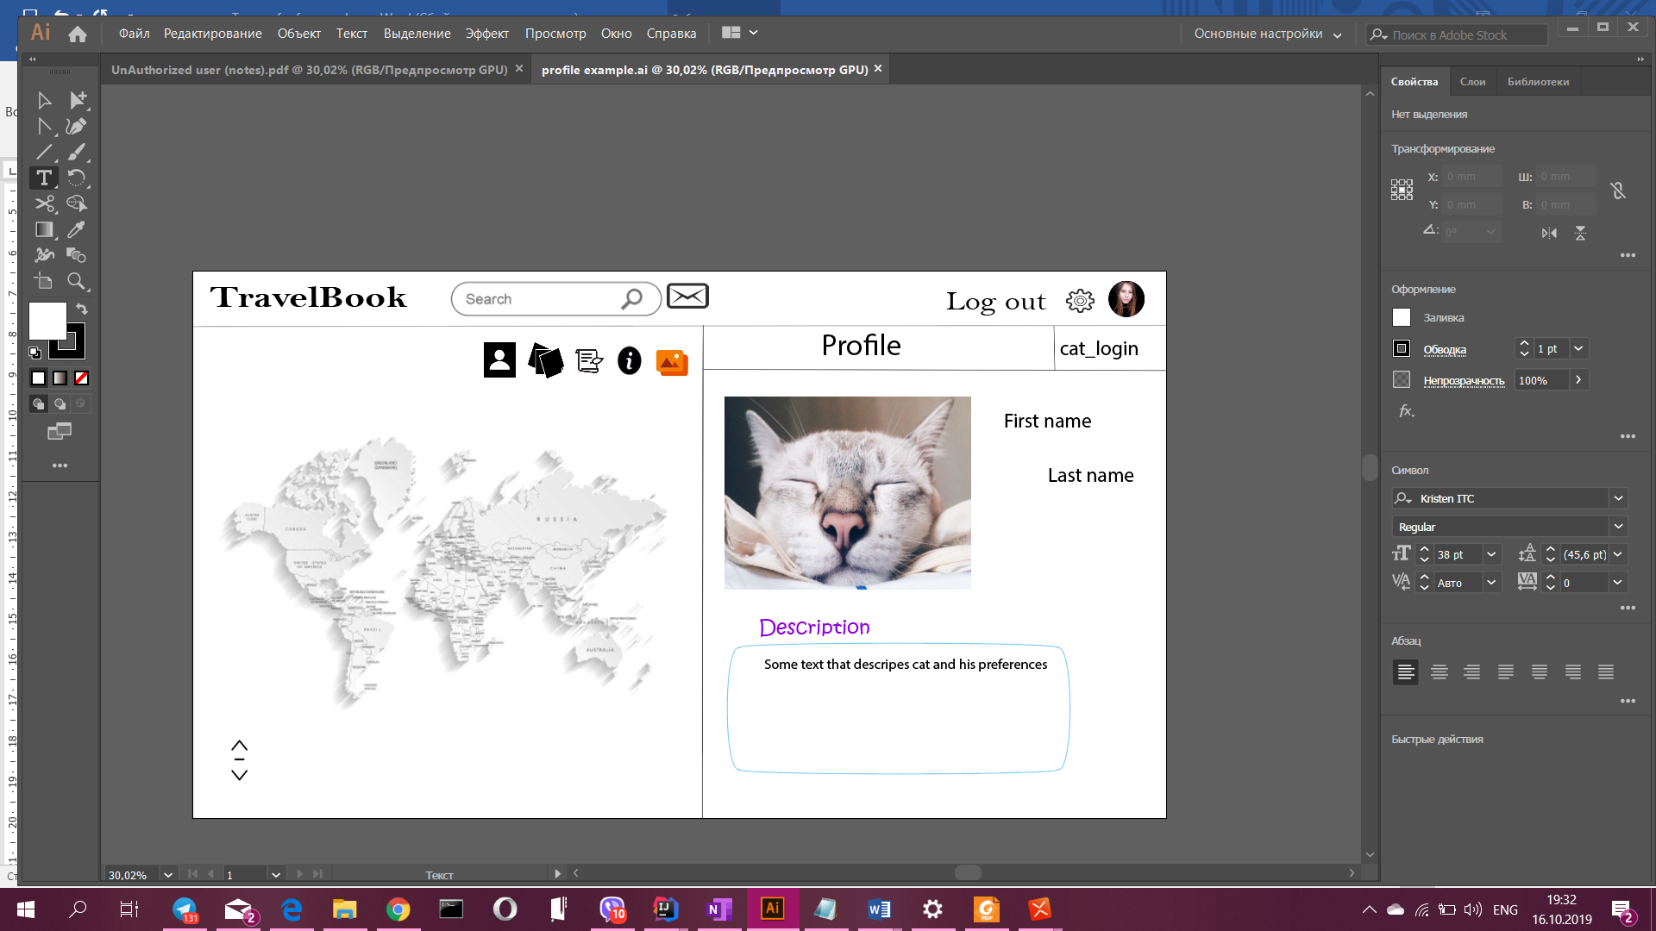

**Searching for countries**

Searching by the country: after selecting the country general information panel will be opened. We can only read peoples notes and look through planned trips. The gallery shows only photos of people, that posted notes connected to this country.

**Recommendations**

This possibility is available in the search. As soon as we click on the search, all the recommendations (accounts) will be listed below.